Sana Akhtar
Frontend Developer · UI/UX Designer · Artist

☎ 0504619943 sanaakhtarx1@gmail.com

⊕ https://sana-
akhtar544.github.io/SanaPortfolio/
- Ajman, UAE

ABOUT ME
TECH STACK & TOOLS

I'm a Creative Computing graduate who loves creating beautiful, usable digital experiences. I

HTML5
CSS
JavaScript
Python
Node.js
GitHub
Figma
Canva

design and build front-end interfaces using
Android Studio
Unity Hub
VS Code
AI / ML
Google API
C++
Circuit

HTML, CSS and JavaScript, and I’m also a artist I paint physical pieces and create scenery and illustrations. I'm seeking roles as a frontend developer, UI designer, or visual artist where I can combine my hands-on art practice with my

PROJECT EXPERIENCE

Emerging Technologies

Group Debate Project

2024

design and coding skills.

EDUCATION

School
Pakistan Islamia Higher Secondary
Analyzed the future of cybersecurity amid increasingly sophisticated cyber threats, with emphasis on
emerging defensive strategies, and participated in group-level debates on ethical and technological implications

School, Sharjah
Creative Industry Challenge

Client Project – Qannas Cargo Services (Website Development)
2024

BSc (Hons) Creative Computing Bath Spa University
RAK UAE (UK Curriculum)
I helped my group in developing a full, responsive website for Qannas Cargo Services, featuring service pages, contact and booking forms, and a simple admin interface; I handled frontend implementation, collaborated on branding, and deployed the site for client use.

Tomorrow's Web

Furry Friends – Animal Shelter Platform
SKILLS
Artwork | 92%
UI/UXDesign | 85%
FrontendDevelop | 90%
JavaScript | 75%
HTML&CSS | 88%
Figma | 80%
Visual Design | 85%
Canva | 90%
LANGUAGES

Built a full‑stack animal shelter website using HTML, CSS, JavaScript and Node.js, implementing frontend and backend features including About, Adopt a Pet, Rehome, Contact Us, Login and Signup pages, plus secure user authentication and admin management.

Physical Computing

Arduino Hardware Project
I prepared the Arduino project proposal: researched sensors and LED components, sketched circuit diagrams, and wrote pseudocode and C++ snippets outlining how I planned to build and control the system.
2025

2026

Personal Creative Work

Artwork
Ongoing

I create original physical artworks paintings, scenic pieces, and sketches and use my hands-on art practice to inspire my UI/UX and visual design work

English Urdu Punjabi
Basic Native Fluent


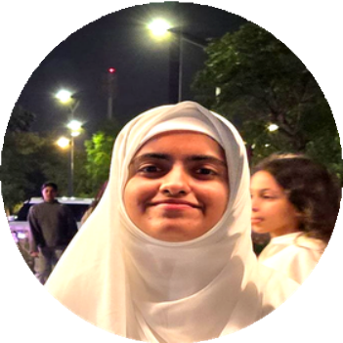




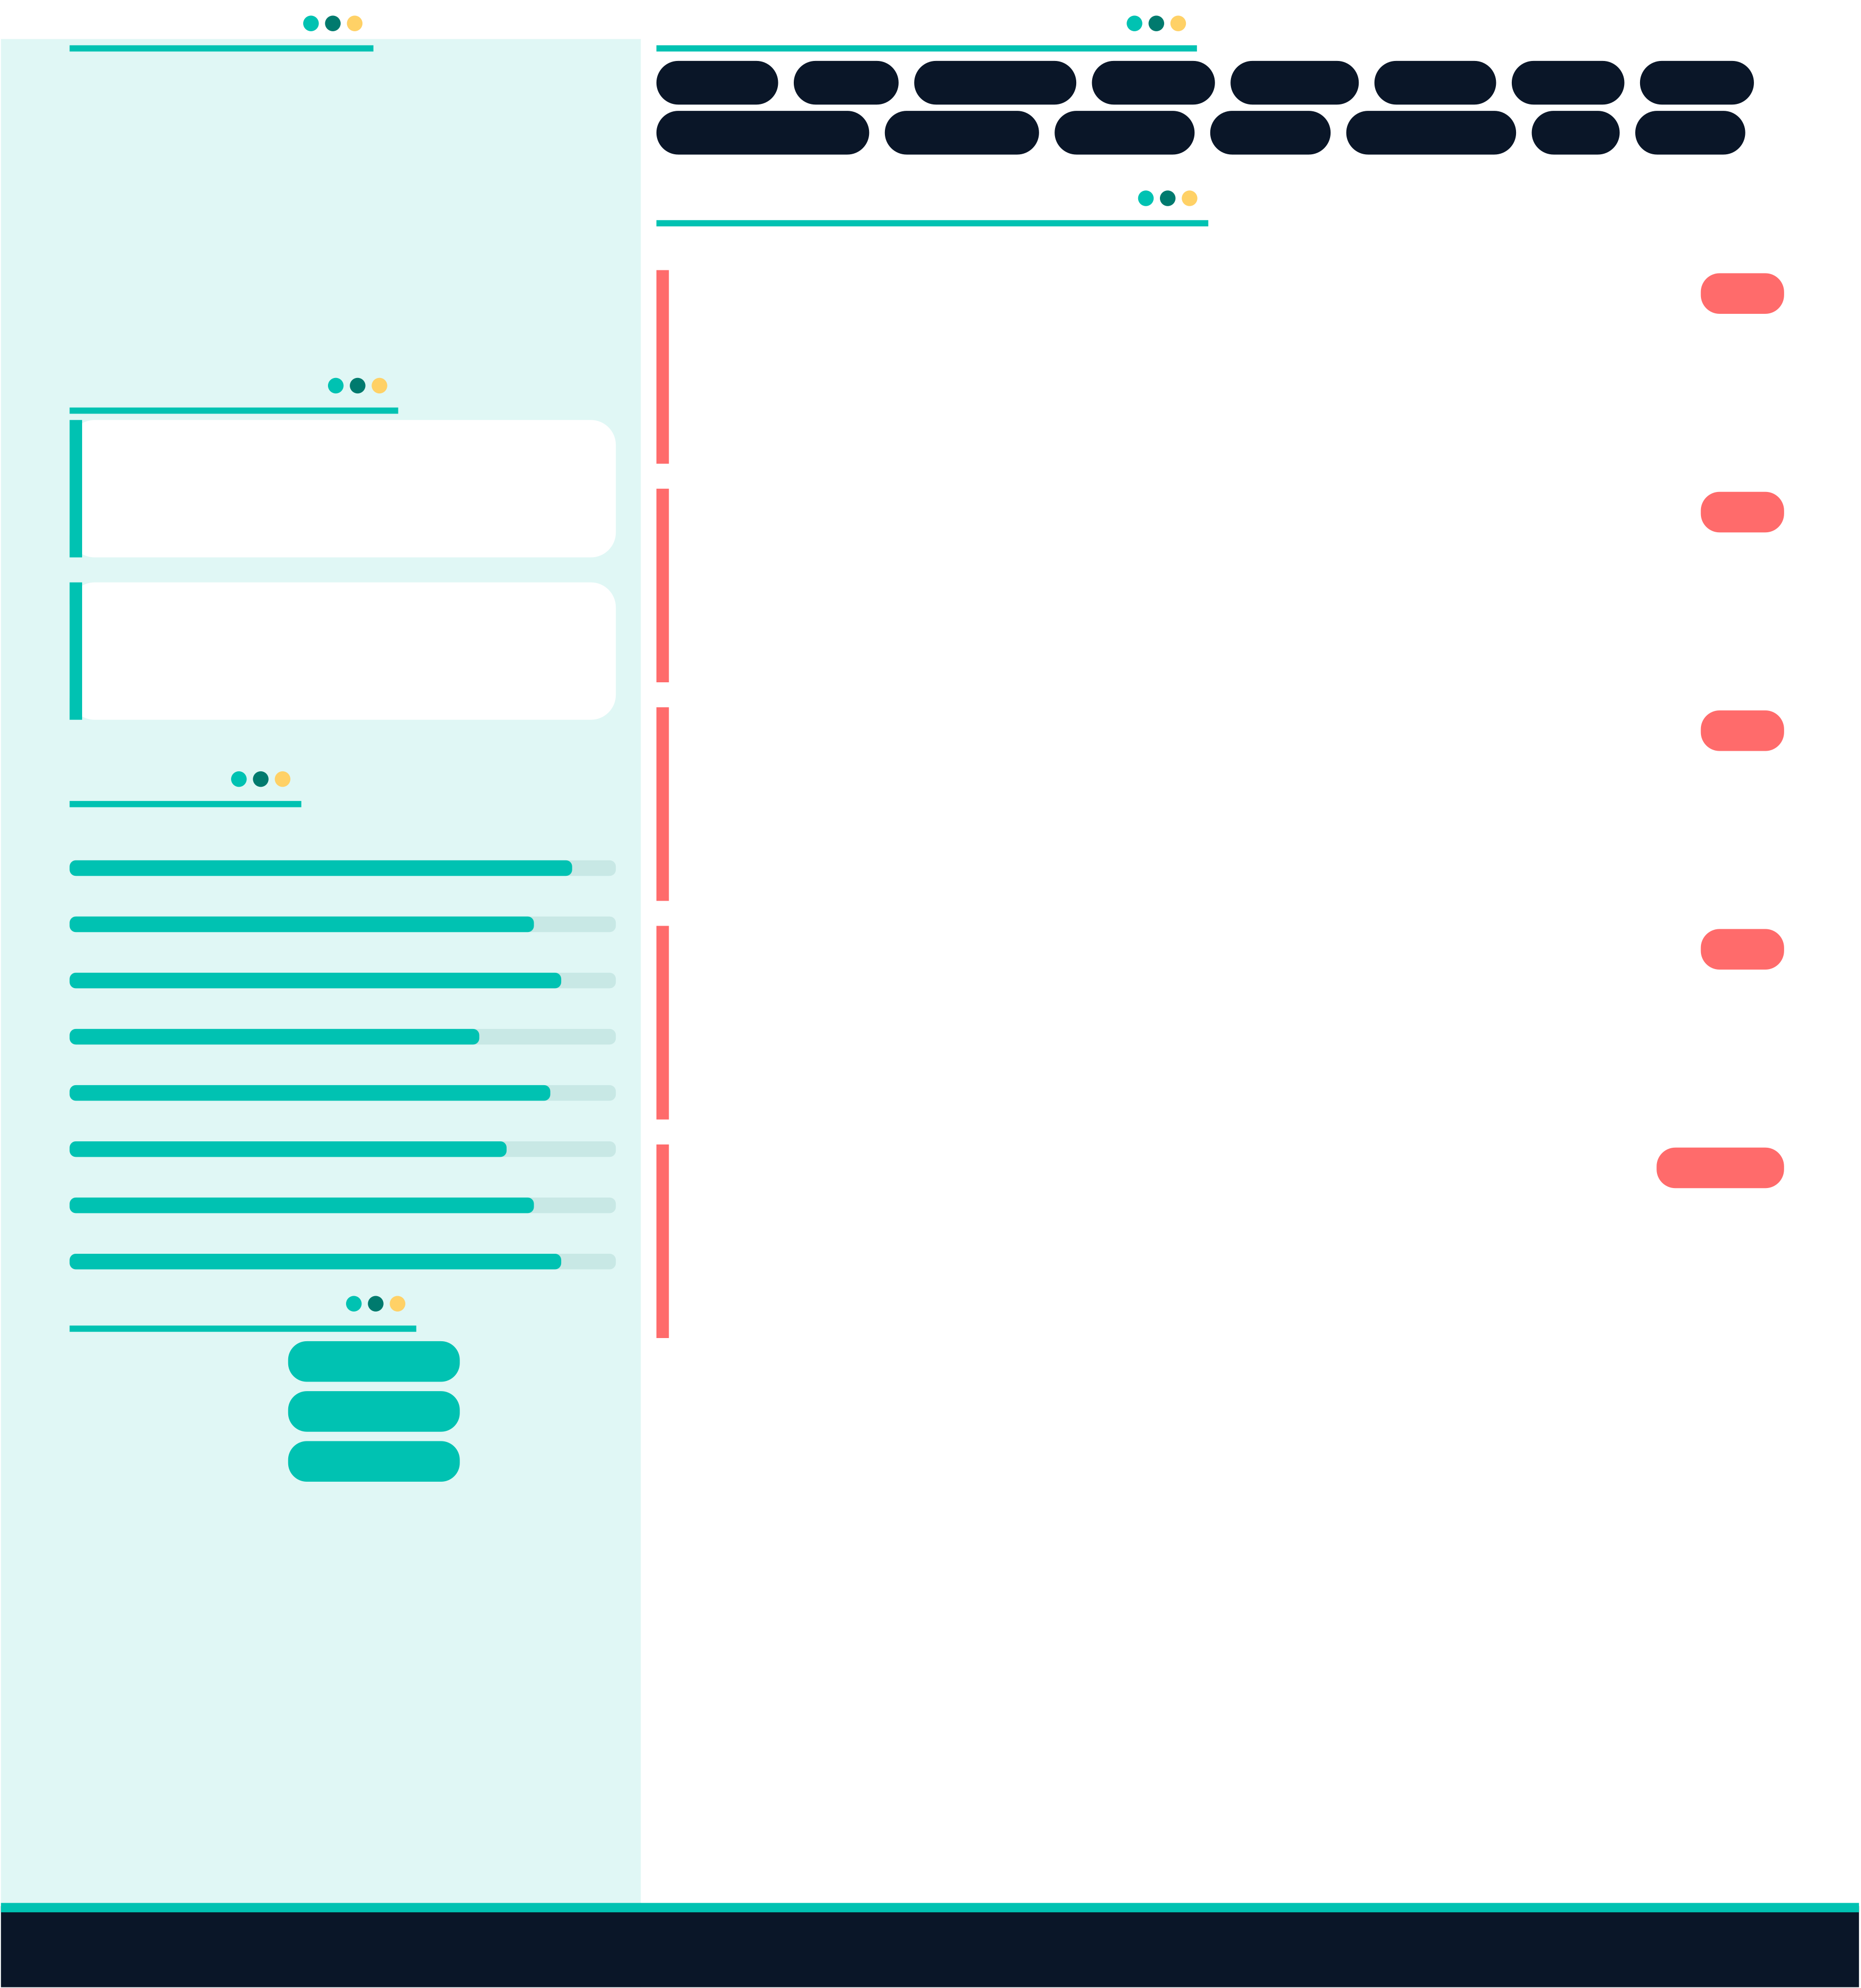

Sana Akhtar ·sanaakhtarx1@gmail.com · 0504619943 · Ajman, UAE

